

**Shopping with**

**Helpee**

AUGUST 1, 2021

CHIẾN BINH COVID - TPDNQ

DANANG, VIETNAM

Table of Contents

I. GENERAL INFORMATION ON THE TOPIC 2

I.1. Project Name: Shopping with “Helpee” 2

I.2. Implementation time: September 4th-12th 2

I.3. Members 2

I.4. Background 3

II. OBJECTIVES, CONTENTS, AND IMPLEMENTATION PLAN 3

II.1. The goal of the subject 3

II.1.1. Status 3

II.1.2. Analysis 4

II.1.3. Solution 5

II.1.4. Conclusion 5

II.2. Status 6

II.3. Overview of the research situation 6

II.4. Content and plan to organize the implementation of the topic 6

II.4.1. Technology used in the project 6

II.4.2. Some demo of product design (canva/figma/photoshop) 9

II.4.3. Actual process 15

II.4.4. Some expansion 16

Products for the contest

BTEC BEST CODER 2021

# GENERAL INFORMATION ON THE TOPIC

The 4.0 industrial revolution has started and impacted every aspects of life, things has become automated, modernized. Consequently, online shopping is a concept that is no longer strange to each of us. Busy is the adjective to describe the life of modern human beings who always revolve around work and do not have time to go to the market. The services of assisting in purchasing items online by supermarkets or applications have been used and favored by many people due to their convenience and speed.

Moreover, in the context of the increasingly complicated covid epidemic, Directive 16 issued by the government to apply to the entire population means that the critizens will not be able to go out until the epidemic is under control. The question raised here is "who will go to the market?", "who will provide food for the people?" and whether people's health can be guaranteed when they are simultaneously suffering from two direct impacts: disease and food shortage. Catching up with the trend as well as understanding the difficulties of the people, we came up with an optimal solution to help people in solving the problem of going to the market. Our project is called: SHOPPING WITH “HELPEE”. Hope that this project will be implemented during this epidemic season and further research and development will be done to match the normal state when the epidemic is over.

## Project Name: Shopping with “Helpee”

## Implementation time: September 4th-12th

## Members

* Nguyen Thi My Duyen (Leader)
* Duong Cong Quan
* Tran Xuan Tu
* Nguyen Dinh Nhat
* Le Van Phong

## Background

In the current complicated situation of Covid-19, the economy, society and all industries has been seriously affected. From an objective point of view, there are actually some web applications that support users to go shopping, but after Prime Minister’s Directive 16 was published, these programs stopped supporting. Although local agencies have embarked on the process of supporting the people, there has not been a specific and systematic program in this period.

Due to the impact of Covid-19, the market economy in our country was congested, economic units stopped operating, leading to the problem of going to the market. Even though there were products to support this work, they almost only focus on serving a specific individual or organisation, but not entirely suitable for new transport units other than shippers such as military units, police, and volunteers.

# OBJECTIVES, CONTENTS, AND IMPLEMENTATION PLAN

## Goal

With difficulties in travel, in the context that the entire population implemeting social distancing during the Covid-19 epidemic according to the Directive 16 in provinces and cities at high risk of epidemic outbreaks or in the complicated situation such as Saigon, Da Nang, Binh Duong, Dong Nai, etc, the appearance of products to support people in this period is extremely necessary. In particular, the issue going shopping is also considered as one of the essential issues and is in dire need of support from the government to reduce traffic volume during this stressful period.

Specifically, with the current situation in the South, especially Ho Chi Minh City, Binh Duong, when the armies, polices, states, and volunteers have participated in activities to support the people go to market, but the management of transportation is an unsatisfactory issue and the transfer process through the leaders of each residential group still has many shortcomings.

### Status

Directive 16 was published with the following main contents:

* Families are isolated from families, villages are isolated from villages, communes are isolated from communes, districts are isolated from districts, provinces are isolated from provinces, workshops and production bases must maintain a safe distance, wear masks, disinfect according to regulations.
* Require all people to stay at home, go out only in case of extremely necessary, stop the operation of most production facilities, service, and goods business establishments.
* Strictly observe the minimum distance of 2m when communicating; do not gather more than 2 people outside of offices, schools, hospitals, and in public places and stop all public passenger transportation.

Therefore, people are not allowed to go outside and in need of supporting to go to the market from other intermediary stages such as the head of the neighbourhood unit or the 3rd parties.

**In reality:** Every certain period of time, the neighbourhood group head will send pictures of the menu of products for people to choose and order. At the end of the day, the head will summarize the papers and then go to the marketand distribute it to each house.

### Analysis

For such a form of direct shopping, it appears that it exists both its own strengths and weaknesses.

**In terms of strengths**: it’s likely that this way is simple, easy to implement and low in maintenance costs.

Whereas,**the inadequacies** in the implementation of this model also causes significant concerns:

* Specifically, this is a complicated process with a cumbersome system, inefficient and costly in both human effort and time.
* Difficulty in preserving data: Papers are at very high risk of being damaged due to external causes such as weather, negligence, etc, which pose a threat to data.
* It takes time to collect orders from buyers: the neighbourhood group head, soldiers, and volunteers will spend time on collecting and synthesizing orders. Simultaneously, this is a job that requires a lot of time because it has to go through many stages.
* Direct communication will increase the risk of infection both for the delivery people and critizens in the area. Simply, it is the delivery people who are susceptible to infection and will become the source of infection for other critizens.
* The management and statistics of data is also a difficult problem because it is done completely manually.

### Solution

Therefore, in the situation of complicated epidemic changes, the more mutations appearing, the more difficulties that people and officials are facing. As a result, a project was planned and launched to solve these problems - a website that supports grocery shopping called Helpee.

**Project strengths:**

* Overcome the shortage of food due to the inability to travel and buy groceries.
* Have friendly interface, support fullly basic functions and be aimed at the average user.
* Be proactive in ordering products
* More systematic and efficient in users and orders management.
* Prevent the situation of not receiving and losing data when buying goods and orders with the help of the others.
* Ensure critizens’ safety.
* Save time and be faster than booking on the app.

**Weaknesses** of the project:

* In order to quickly release to meet users’ needs, the project was developed in a short of amount of time, so an eye-catching interface is not the strong point of this project.
* Simultaneously, the project is limited in terms of functions

🡪 Will be improved in the future

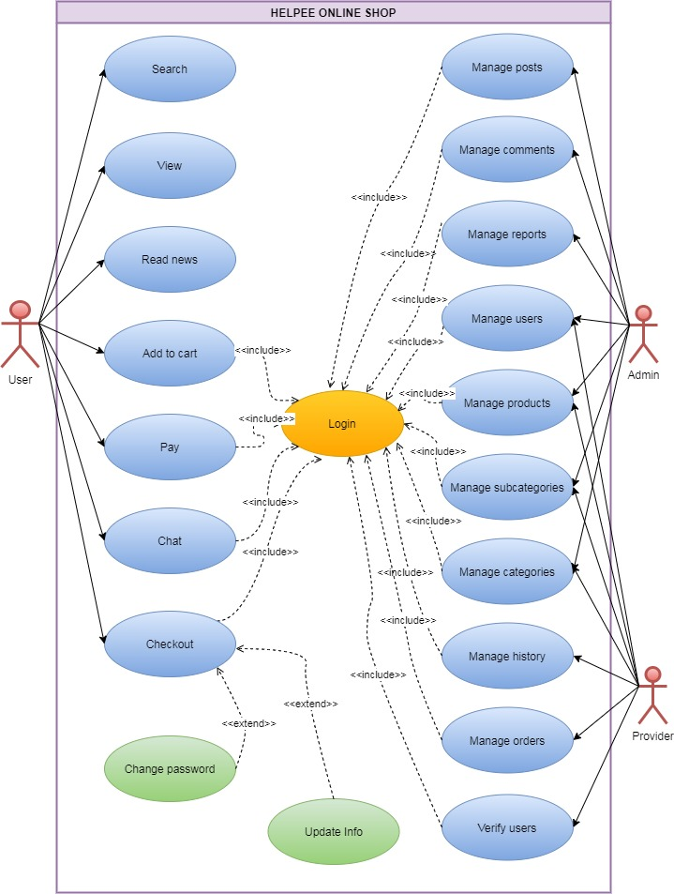

Figure II.1: Use case

### Conclusion

This website aims to support the problem of household shopping, minimizing the work of intermediaries such as the head of the residential area, etc.

For traditional delivery with current systemsin the market, a carrier like a shipper only has information about a specific order. But with Helpee, the website will support the buying units to be able to manage and statistics all the orders in the area. The units in the wards can access and manage data. The differentiation of accounts also directs them to the data provided by their ward, thereby provide better supporting the ordering, shopping, and receiving services.

In order to meet the specific needs of the present, and take inspiration from the online shop websites, Helpee was created, aiming to be a simple website that meets the most important needs with the army-critizen model. Of course, to ensure sustainability, in the future, Helpee will add other expanded features such as online payment via bank account, donation function to support people who are in difficulty because of Covid-19, etc.

## Project status

This is a new project that we jointly designed, built, and implemented. The topic was discovered when the epidemic in Vietnam became more and more complicated, the problem of food supply was not guaranteed. It was inspired by the the idea of home delivery services by online websites developed and based on a dense network of delivery people before Covid-19.

## Overview of the research situation

With the continuous development of e-commerce application services and the change in people's needs, the "at-home" shopping service is gradually becoming popular in cities and urban areas.

In the current Covid epidemic situation, going to the market services play a crucial role in protecting all critizen’s health and safety.

Currently, there are many reputable and quality sources of application development such as bTaskee and chopp.vn.

## Content and Plan

### Technology used in the project

* **Front end**

About the interface

* Using HTML5 - a new version of HTML - provides new tags, new attributes
* Using CSS3: provides selectors ([attribute^=value]), Pseudo-Classes (like :link, :hover, :active, :visited, :focus), RGBA, etc.
* Help create the best possible UI using animate to create effects that make the user experience better.

Apply knowledge of Web SEO:

* Using meta tags with description attribute, set icon, title, Facebook Open Graph, and some other social networking sites.
* Trying to upgrade SSL to use HTTPS to solve the problem of Google penalizing websites, reducing the appearance in the top search.
* On pages, using only one h1 tag and use other tags reasonable and functional, such as inline tags that do not contain block tags, etc.
* Using higher packages when registering hoisting/domain services, creating minify HTML, CSS, js to improve loading speed, compressing image files, adding an alt attribute to image tag
* Limiting the use of JavaScript to build the object, using CSS with the style attribute display: none/block instead.
* Fixing 404 errors, allowing the website to display on search servers to make the website responsive because the mobile traffic is quite large.

To support the interface process, we can choose one of two frameworks: tailwind CSS or bootstrap 4.

In addition, we use JavaScript that comes with VUEJS framework version 2 (for stability) along with some packages like JSON-sever, ESLINT, babel, Axios, and technologies like AJAX, API to communicate with backend in handling data (like JSON or XML). Using Figma/photoshop in standard interface design according to Bootstrap. Understanding UI/UX such as primary color (#FFF), secondary color (#EE4D2D) and CTA (call to action). The interface is also designed according to the gird module to make it easier to convert design files into HTML/CSS. Also, we use API/SVG canvas tags to create 2D, 3D effects, Geolocation API and rely on the user's public IP to track relative location.

* **Back end**

Using PHP programming language and MySQL database management system to store the database in fields that are PHP limitations: apply object-oriented knowledge in PHP: classes, namespaces, constructor, extend, instance, static methods, interface, abstract, trait, etc and other PHP-specific knowledge such as session, cookie, request param, etc.

Use UML diagrams to analyze and learn how to analyze and design relational databases to meet the requirements of the given problem. With basic knowledge of SQL, time, or implementation, back-end deployment uses Nodejs running on Heroku to create APIs that communicate with the frontend.

For deployment and development, we use git to manage versions and this is also the solution in teamwork problems, use GitHub and git page to be able to use free hosting and access websites online and use GitLab to manage working versions during development.

### Some demo of product design (canva/figma/photoshop)

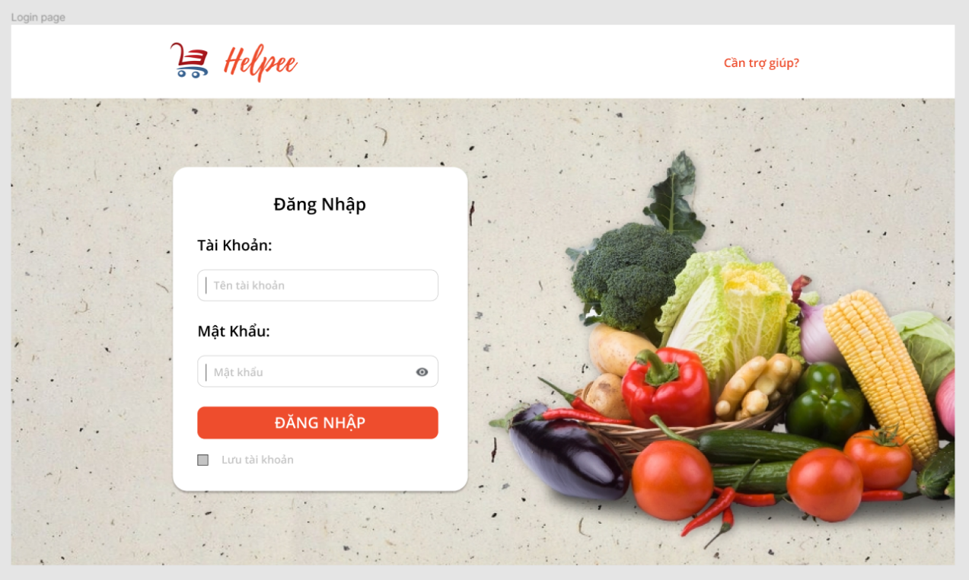

Figure II.2 Trang Đăng Nhập

The website's login page includes an account and password provided locally for each household, each household will be given a certain account. After login for the first time, they will enter their infomation and use this account to order.

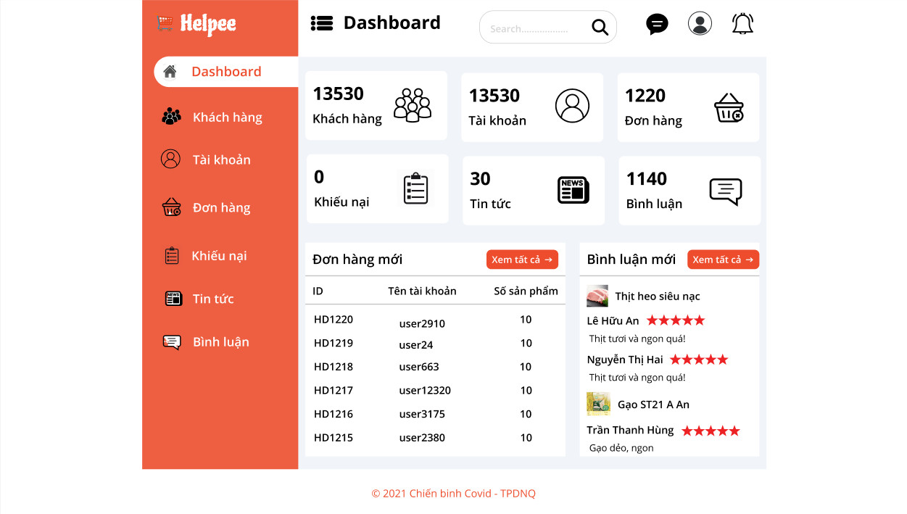

Figure II.3 Admin Page

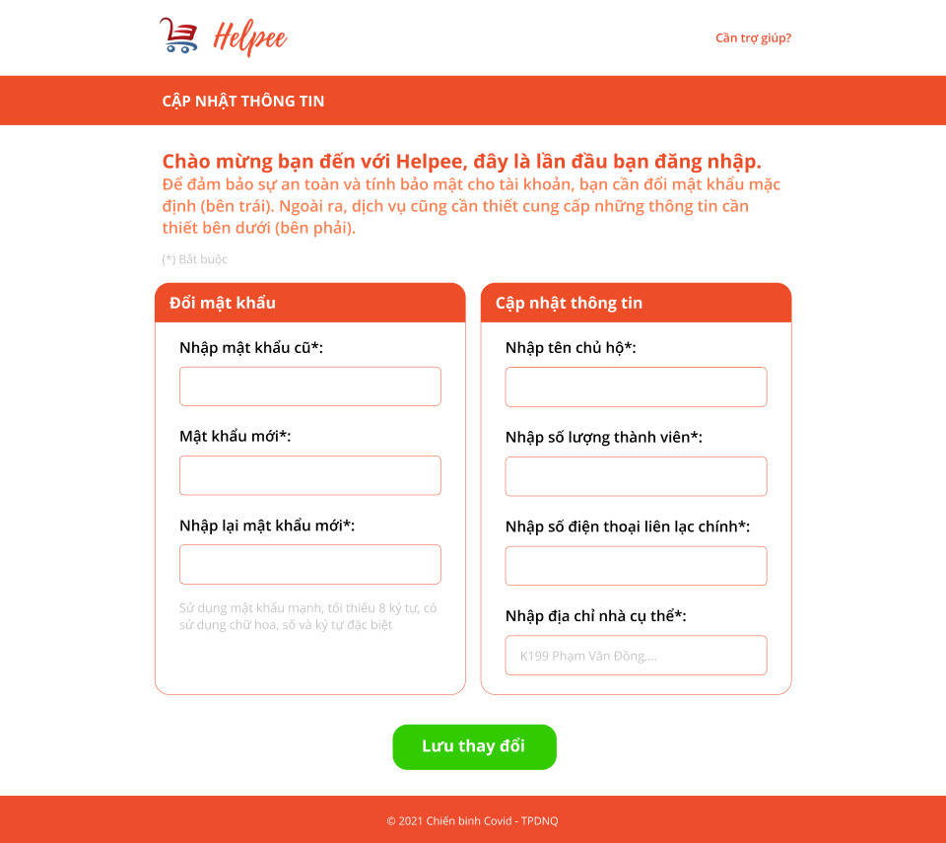

Figure II.4 Information Update Page

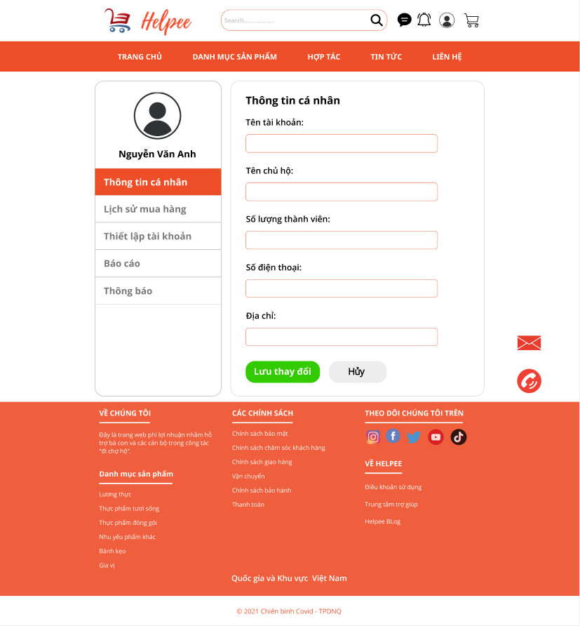

Figure II.5 Account Page

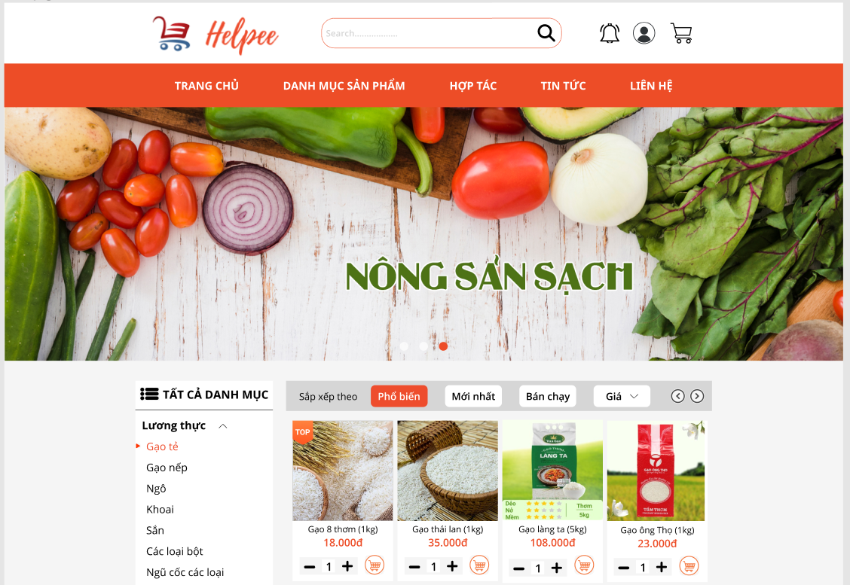

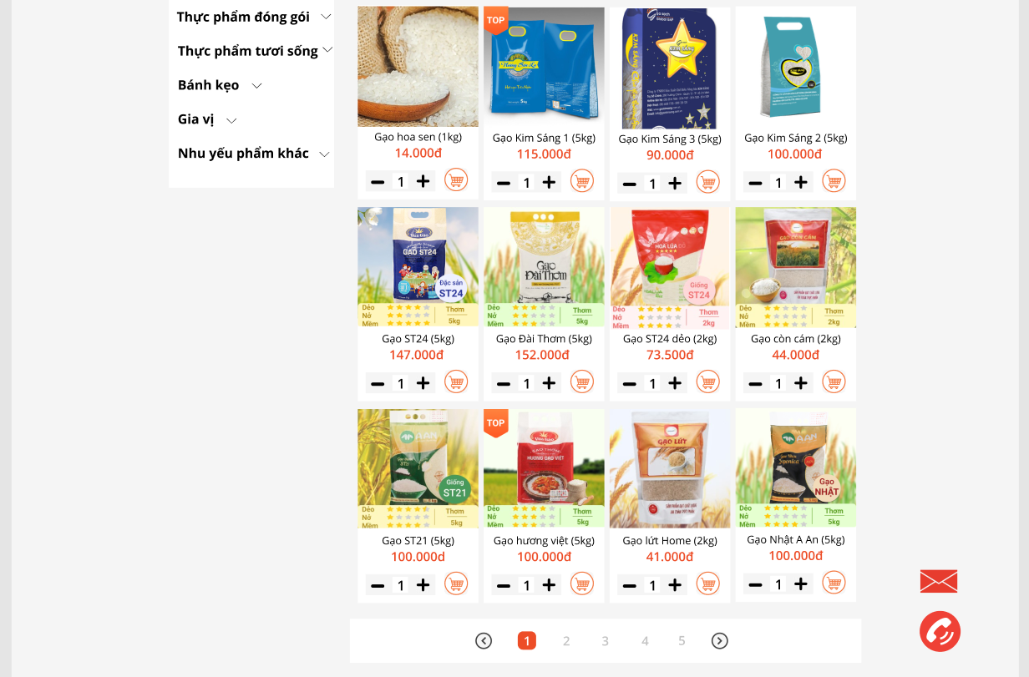

Figure II.6 Product Category Page

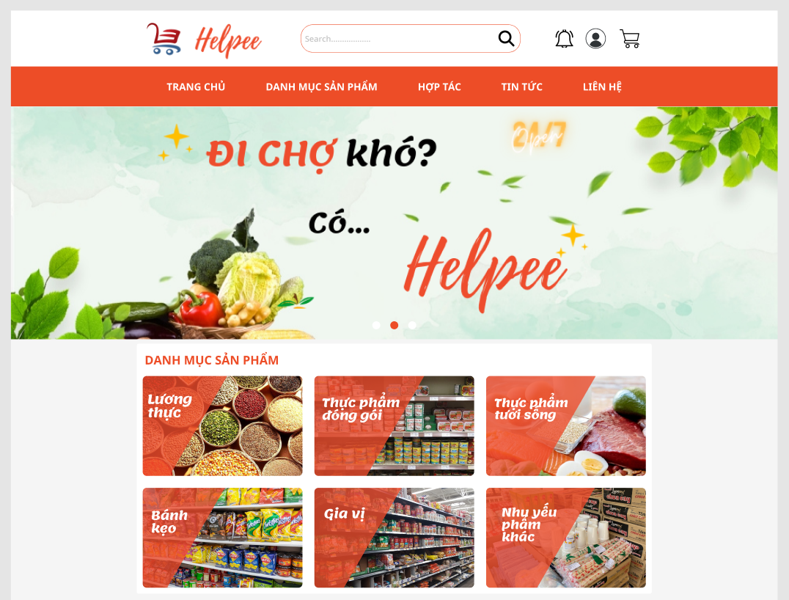

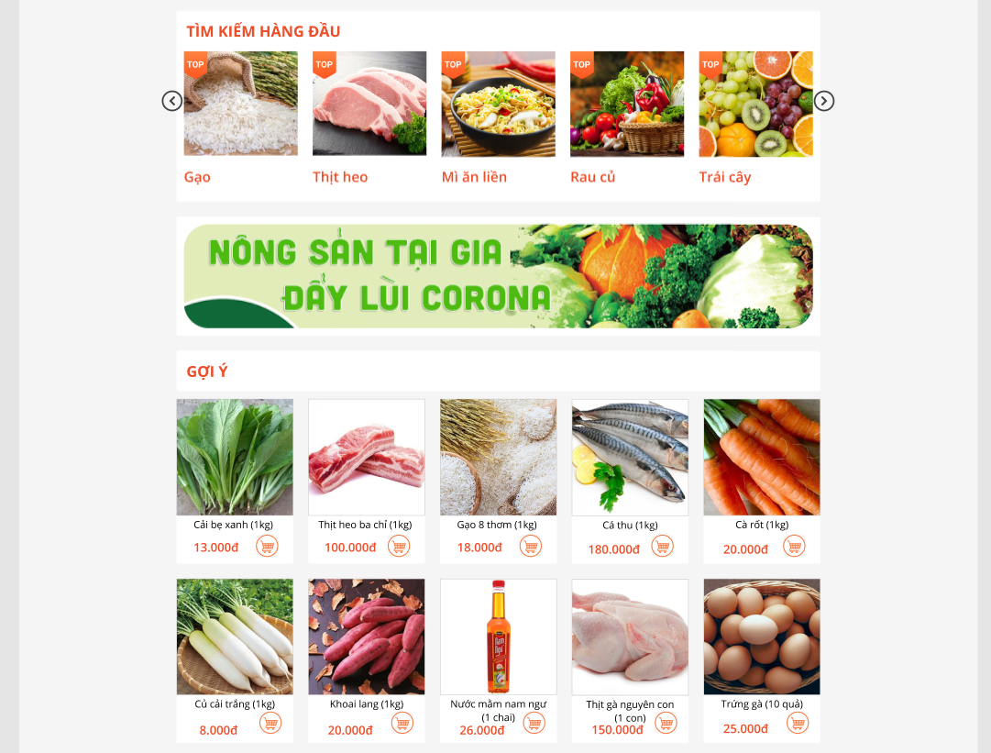

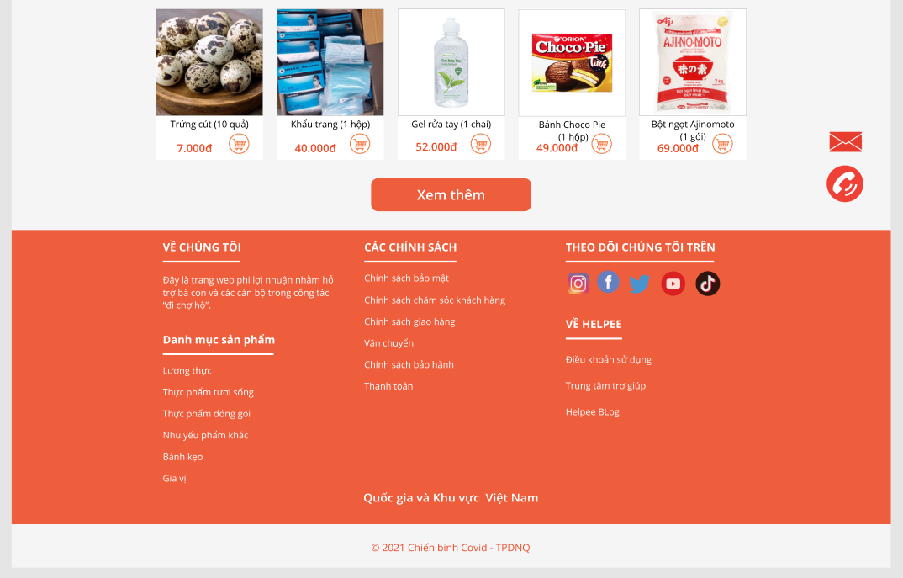

Figure II.7 Main Page

These above design described the user interface when login to the system. We analyze and prioritize customer satisfaction so the interface will be arranged clearly.

### Actual process

Table 1: Project plan

|  |  |  |  |  |
| --- | --- | --- | --- | --- |
| ***Content*** | | **Result** | **Time** | **Responsible by** |
| *Analyse the requirement* | | The report | 4/9 - 6/9 | All team |
| *Write report* | | Document | 5/9 - 8/9 | Duong Cong Quan, Nguyen Dinh Nhat |
| *Make the presentation* | | Document | 8/9 - 10/9 | Le Van Phong |
| *Design* | | Document | 6/9 - 9/9 | Tran Xuan Tu |
| *Do the presentation* | | Presentation | 20/9 -10/10 | Tran Xuan Tu |
| *Implementation* |  | Application | 10/9 – 20/9 | All team |
| *Login Page* |  | 10/9 - 11/9 | Duong Cong Quan |
| *Home Page* |  | 13/9 - 15/9 | Le Van Phong |
| *News Page* |  | 13/9 - 15/9 | Duong Cong Quan |
| *Provider Page* |  | 15/9 - 17/9 | Tran Xuan Tu |
| *Admin Page* |  | 14/9 - 15/9 | Nguyen Thi My Duyen |
| *Purchase Page* |  | 18/9 - 19/9 | Nguyen Thi My Duyen |
| *Database design* | | Application | 18/9 - 20/9 | Nguyen Dinh Nhat |
| *Testing* | | Test case | 20/9 | Nguyen Thi My Duyen |
| *Maintainence* | | Application | 20/9-10/10 | All team |

### Some expansion

Future improvement functions:

* Donate function: We receive funds that people and benefactors transfer which is stated with clear and authentic documents. All this money will be completely converted into food and foodstuff, and essential products to provide to the people in epidemic areas.
* Drug delivery function: We will contact with drug delivery units to supply medicines.
* Messaging and video calling function: This page is used with 3 permissions: everyone – local – selected people. As a result, people can comment, text and call each other, to provide information about people who are in need of help, or to report common problems or shortcomings of the system.
* Receiving goods from relatives function: We will further improve this function because some families will encounter financial difficulties in going to the market and in need of delivering food from other places. This additional function of receiving items will help the neighbourhood group head so that the goods can be easily managed and delivered to the people as soon as possible.
* Updating news about the epidemic function: We will update official news sources of the country and post them on the website.
* Currently, we only have 2 main payment methods, which are to pay in advance and to pay via PayPal. However, registering for pay via PayPal requiring a visa card, we will have upgrades for this. Thanks to this, people can pay for purchases conveniently, because it is very difficult not to go out and have cash available. We will link up with most banks with online money transfer applications such as MoMo, Viettel pay, Zalo Pay, etc.
* Because of the limited working time, after successfully deploying on the website, we will proceed to build and develop an application system to make the people's experience better.
* In addition, we also upgrade and maintain the system regularly, so that the system works best will its full performance.